CURRICULUM VITAE
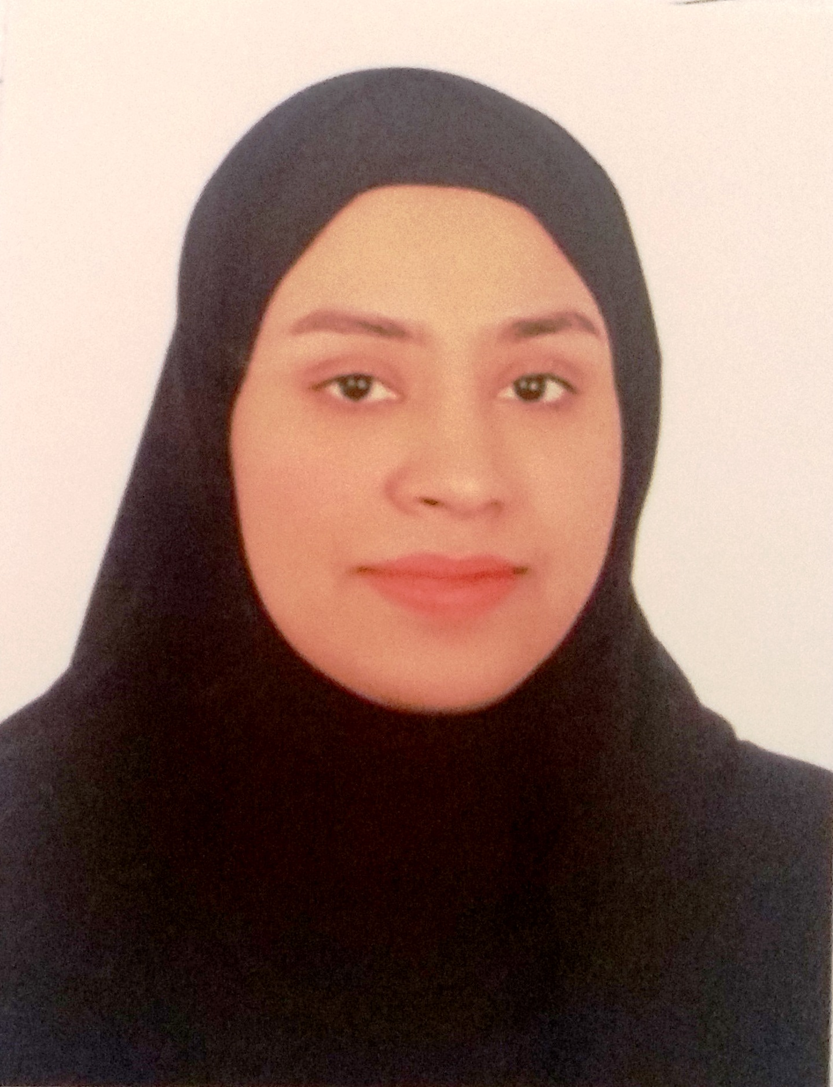

Name: Ayat Mahdi Ail Salman
Address: Villa 5 Road 2601 karzakkan 1026
E-mail: Ayat278@gmail.com
Mobile: 35631022

Career objective:
To grow as an effective professional and drive the organization toward higher targets as well as help myself to strengthen my job competency and grow within the company.

Personal Data:
- Date of Birth : 27/8/1993
- Nationality : Bahraini
- Marital Status : Married

Education:
- (2011- 2017 ) Bachelor of sociology and psychology - University of Bahrain.
- (2008 – 2010 ) High school certificate - Jedhafs secondary School.

Skills:

Languages | - Arabic  - English
IT Skills | Microsoft office:  - word  - power point  - Excel
Skills | - Hard worker  - Work under pressure  - Create clear PowerPoint presentations  - Research work
References:
Upon Request

